Integration of Acupressure and Phytotherapy as a Complementary Modality to Managing Sleep Disorders and Cephalgia in Hypertensive Elderly: Case Study
Dewi Umu Kulsum¹*, Khrisna Wisnusakti², Rini Mulyati³
¹²³Faculty of Health Sciences and Technology, Jenderal Achmad Yani University.
*Correspondence: dewi.umukulsum@lecture.unjani.ac.id
Abstract

Methods: This two-case study involved a 68-year-old woman and a 71-year-old man with hypertension, sleep complaints, and recurrent headaches. For seven days, participants received acupressure twice daily and herbal preparations containing ginger, lemongrass, and other ingredients, alongside routine antihypertensive treatment, sleep-hygiene education, and relaxation breathing. Outcomes were blood pressure, headache intensity, nighttime awakenings, subjective sleep observations, and Pittsburgh Sleep Quality Index (PSQI) scores before and after the intervention. Results: In case 1, blood pressure changed from 145/85 to 120/75 mmHg, headache intensity from 4/10 to 1/10, and PSQI score from 12 to 7. In case 2, blood pressure changed from 150/90 to 140/90 mmHg, headache intensity from 2/10 to 1/10, and PSQI score from 12 to 7. Both participants reported fewer nighttime awakenings and greater calmness before sleep. No nausea, dizziness, or discomfort was reported. Conclusion: Improvements were observed during the seven-day period. However, because the intervention involved two cases, concurrent components, and ongoing antihypertensive treatment, causal effects cannot be determined. Further standardized studies are needed.

Keywords: acupressure; herbal; hypertension; sleep disorders; community
INTRODUCTION
Hypertension is one of the most common chronic health problems experienced by the elderly and is a leading cause of morbidity and mortality worldwide. According to (WHO, 2021), approximately 46% of the elderly worldwide experience hypertension, and one-third of them complain of recurrent headaches and chronic sleep disturbances. Global data indicates that over 1.28 billion people worldwide live with hypertension, with two-thirds of them residing in developing countries (Zhou, et al, 2021); (Mills, et al, 2016). In Indonesia, the prevalence of hypertension among the population over 18 years old reaches 30.8% (Kementerian Kesehatan Republik Indonesia, 2023), and increases to 63.2% in the elderly group (Riskesdas, 2023). This disorder affects nerve and cardiovascular function, and increases the risk of complications such as heart disease, stroke, and decreased vital organ function.
According to Law of the Republic of Indonesia Number 13 of 1998, a person is categorized as elderly if they are 60 years of age or older. Based on data from the Central Bureau of Statistics (BPS, 2023);(BKKBN, 2024), the number of elderly people in Indonesia reaches 31.01 million, or about 11.75% of the population, and is estimated to continue increasing each year. As people age, the elderly experience physiological changes that affect blood pressure, cerebral circulation, and the balance of the autonomic nervous system. This condition explains why hypertension is often accompanied by headaches due to increased intravascular pressure in the brain's blood vessels, as well as sleep disturbances triggered by the activation of the sympathetic nervous system. Increased levels of stress hormones like cortisol and decreased peripheral vasodilation worsen blood pressure, creating a vicious cycle between hypertension, headaches, and sleep disturbances that ultimately reduces the quality of life for the elderly.
One common symptom in elderly individuals with hypertension is headaches caused by increased intravascular pressure in the brain's blood vessels, as well as sleep disturbances often triggered by an imbalance in the autonomic nervous system. Activation of the sympathetic nervous system due to physiological and psychological stress can disrupt the sleep cycle, making it difficult for older adults to reach the restorative deep sleep phase. Recurrent sleep disturbances will worsen blood pressure thru increased cortisol hormone levels and decreased peripheral vasodilation. This creates a vicious cycle between hypertension – headache – sleep disturbances, which ultimately reduces the quality of life and well-being of the elderly.
Pharmacological approaches are indeed the primary therapy for controlling hypertension, but limitations are often encountered in the elderly, such as drug side effects, low medication adherence, and accompanying metabolic disorders. Therefore, safe, simple, and non-pharmacological complementary therapies are needed that can help reduce complaints naturally. Acupressure, a technique of gentle pressure on specific meridian points, helps restore the body's energy balance (qi), improve blood circulation, and stimulate the parasympathetic nervous system. (Rahmayanti, et al, 2018); (Wang, et al, 2023);(Damiati, N., & Wulandari, 2021) show that play therapy for children with special needs improves motor function and patient well-being. Some acupressure points used in the treatment of hypertension and sleep disorders include LR3 (Taichung), KI3 (Taix), and HT7 (Shen men). Stimulating this point has been shown to lower blood pressure, reduce headaches, and improve sleep quality by better relaxing the nervous system.
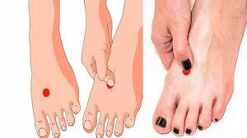
Figure 1. Acupressure Point LR3
References: https://albanacupuncture.com/boost-qi-kidney/
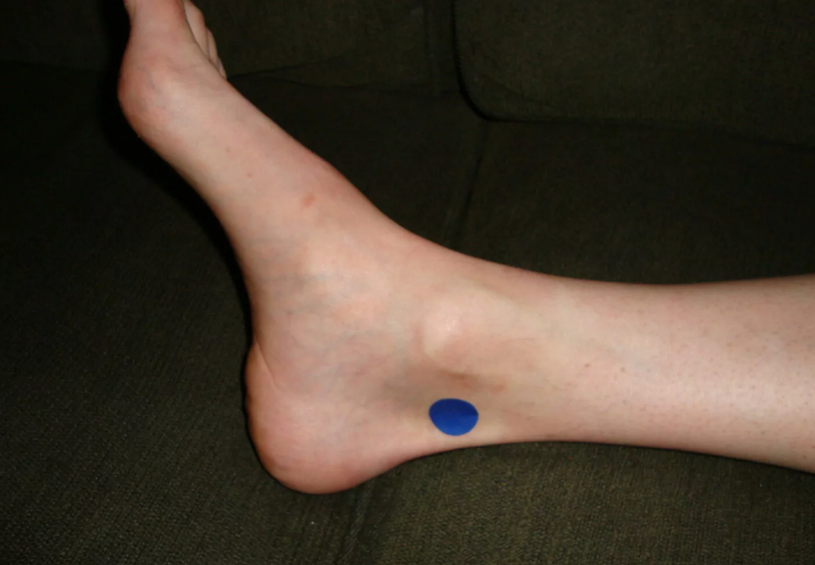
Figure 2. Acupressure Point KI 3
References: https://albanacupuncture.com/boost-qi-kidney/
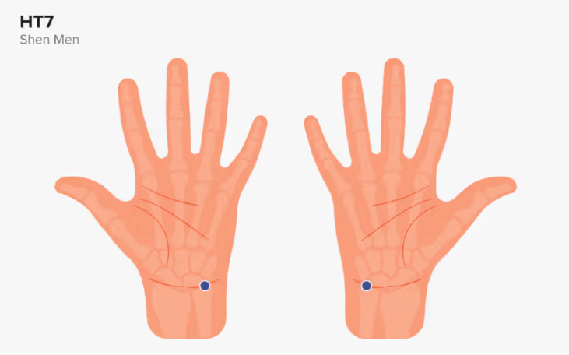
Figure 3. Acupressure Point HT 7
References: https://www.medicalnewstoday.com/articles/327274#ht-7
Beside acupressure, herbal therapy (phytotherapy) is also a complementary approach that supports natural healing. In this study, two types of herbal teas were used: relaxation herbal tea and traditional ginger herbal drink, which contain natural ingredients with complementary pharmacological effects:
Relaxation herbal tea containing lemongrass (Cymbopogon citrates), butterfly pea flower (Clitoria ternate), lemon (Citrus limon), ginger (Zingiber officinale), and cloves (Syzygium aromaticum). This combination has an antioxidant effect, calms the nervous system, and improves cerebral blood circulation.
A traditional ginger herbal drink made from ginger, lemongrass, salt, and palm sugar. This concoction works to warm the body, improve blood circulation, and stimulate the release of endorphins, which can reduce headaches and improve sleep quality (Han, et al, 2021); (Sulendri, et al, 2022).
The purpose of this study is to examine how two elderly respondents with hypertension in Cipageran Village, North Cimahi, experienced a reduction in headache pain and improved sleep patterns as a result of a combination of acupressure and phytotherapy, which is expected to work synergistically to reduce headache complaints, improve sleep quality, and stabilize blood pressure. This dual case study approach is expected to provide empirical insights into the effectiveness of community-based complementary therapies that are safe, simple, and easy for the community to implement.
METHODS
Research Methods
Using a descriptive qualitative case study design, this research aims to comprehensively explain the use of acupressure and herbal therapy in two older respondents suffering from hypertension, sleep disturbances, and headaches. This study was conducted for seven consecutive days in July 2025 in Cipageran Village, North Cimahi District, Cimahi City.
Research Subjects
Two adults meeting the following criteria were research subjects: (1) over fifty years old; (2) diagnosed with hypertension; (3) experiencing sleep disturbances and headaches; (4) had never undergone acupressure therapy or taken other herbal remedies; and (5) were willing to participate by signing an informed consent form. Initial research findings and criteria suitability determined the selection of respondents thru purposive sampling.
Data Sources and Collection
Clinical measurements before and after the intervention, direct observation, and structured interviews are the methods used to obtain research data. Data collection was carried out by the researcher in collaboration with community nursing staff, adhering to ethical principles and patient data confidentiality.
Research Instruments
The instruments used include:
1. Measure systolic and diastolic blood pressure using a standard digital sphygmomanometer on the blood pressure observation sheet.
2. Numeric Rating Scale (NRS) for assessing headache pain intensity with a score range of 0–10.
3. A sleep pattern observation sheet that records the frequency of awakenings, sleep duration, and the patient's subjective sleep quality before and after the intervention.
Data Analysis
The qualitative descriptive data analysis process was used to compare the respondents' conditions before and after the intervention, including blood pressure, pain scale, and sleep quality. To show the changes, the data is presented in the form of clinical narratives and tables. Additionally, source triangulation of observations, interviews, and measurement records was used to validate the results and ensure their accuracy.
RESULTS
Case Illustration
This case involves two elderly respondents, a 68-year-old woman and a 71-year-old man, with a history of essential hypertension for ≥ 5 years. Both reported the main complaints of recurrent headaches, a heavy feeling in the neck, and difficulty sleeping for more than three months. Initial examination showed an average blood pressure of 150/90 mmHg, a pulse rate of 74–80 beats per minute, and a Visual Analog Scale (VAS) score for headache pain of 7 (severe category). Sleep quality was measured using the Pittsburgh Sleep Quality Index (PSQI) with an initial score of 12 (severe sleep disturbance).
Neither respondent was taking sedatives and both continued their routine antihypertensive therapy (Amlodipine 5 mg/day) as prescribed by their doctor. They are willing to undergo complementary interventions by signing informed consent.
Table 1 shows the clinical characteristics of the two respondents.
Table 1. Clinical Characteristics of the Two Respondents
Characteristic | Case 1 | Case 2
Age (years) | 68 | 71
Sex | Female | Male
Diagnosis | Essential hypertension | Essential hypertension
Hypertension duration | ≥ 5 years | ≥ 5 years
Main complaint | Recurrent headache; difficulty sleeping | Recurrent headache; difficulty sleeping
Baseline blood pressure | 145/85 mmHg | 150/90 mmHg
Baseline headache intensity (VAS) | 4/10 | 2/10
Baseline PSQI score | 12 | 12
Routine medication | Amlodipine 5 mg/day | Amlodipine 5 mg/day
The study results show stable vital signs, with subjective complaints of throbbing pain in the occipital and temporal regions, which increases with fatigue or stress. Respondents also reported difficulty sleeping, waking up frequently at night, and feeling unrested upon waking in the morning. Nursing examination showed a disturbed sleep pattern, moderate stress level (DASS score 16–18), and an average sleep duration of 4–5 hours per night.
Major nursing problems identified
Discomfort (headache) is related to increased blood pressure and neck muscle tension.
Sleep pattern disturbances are associated with physical and psychological discomfort.
Interventions (Acupressure and Phytotherapy)
The intervention was conducted for 7 consecutive days, with each session lasting approximately 30 minutes and consisting of two components:
Acupressure
Performed at points related to head, neck relaxation, and blood pressure regulation:
GV20 (Baihui): The crown of the head, promoting energy flow and cerebral circulation.
GB20 (Fengchi): Back of the head, relieves headaches and vertigo.
LI4 (Hegu): Back of the hand, reduces tension headaches.
HT7 (Shenmen): Wrist, improves sleep quality.
PC6 (Neiguan): Inner wrist, helps with relaxation and balancing blood pressure.
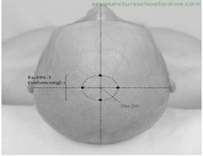
Figure 4. Acupressure Point GV20 (Baihui)
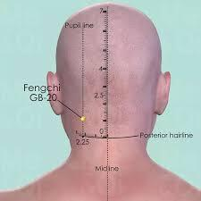
Figure 5. Acupressure Point GB20 (Fengchi)
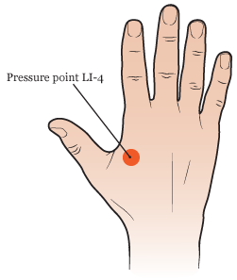
Figure 6. Acupressure Point LI4
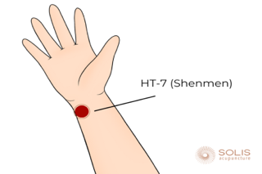
Figure 7. Acupressure Point HT7
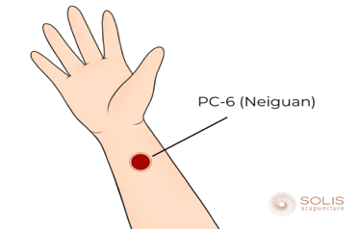
Figure 8. Acupressure Point PC6
The technique is performed by applying thumb pressure for 2–3 minutes per point, rotating clockwise with moderate intensity.
Phytotherapy
Given in the form of warm herbal infusions, taken twice a day (morning and evening) after meals for seven days. Its composition consists of:
Containing ginger, lemongrass, salt, and brown sugar, the traditional ginger drink reduces muscle tension, improves blood circulation, and warms the body.
Relaxation herbal tea consists of ginger, lemongrass, butterfly pea flowers, cloves, and lemon, which have antioxidant, calming, and mild vasodilator effects, helping to improve relaxation and sleep quality.
Patients are also educated about relaxation breathing exercises and sleep hygiene (establishing a regular sleep schedule, avoiding caffeine, and creating a quiet sleep environment).
Respondents were also educated on sleep hygiene (establishing a regular sleep schedule, avoiding caffeine, creating a comfortable sleep environment) and relaxation breathing exercises.
Outcome Evaluation
After seven days of intervention, both respondents showed a reduction in blood pressure, decreased headache intensity, and improved sleep quality.
Table 2 shows the observed outcomes before and after the seven-day intervention.
Table 2. Observed Outcomes Before and After the Intervention
Outcome | Case 1 | Case 2
Blood pressure (mmHg) | 145/85 → 120/75 | 150/90 → 140/90
Headache intensity (VAS) | 4/10 → 1/10 | 2/10 → 1/10
Nighttime awakenings | 3/night → 2/night | ≥3/night → 1/night
PSQI score | 12 → 7 | 12 → 7
Sleep quality | Not restful; restless → More restful; calm | Difficulty sleeping; easily anxious → Fell asleep faster; calm
Post-intervention emotional condition | More relaxed and energized | Calmer and more relaxed
Subjectively, both respondents reported a reduction in pulsating headache, a sensation of lightness in the neck, and an increased feeling of calm during sleep. No side effects such as nausea, dizziness, or discomfort were reported after the therapy.
DISCUSSION
Discussion and Case Significance
This case demonstrates that the combination of acupressure and phytotherapy can synergistically reduce headaches, stabilize blood pressure, and improve sleep quality in older adults with hypertension.
Acupressure stimulates the parasympathetic nervous system, enhances blood circulation, and reduces excessive sympathetic activity. These findings align with studies by (Kulsum, et al, 2025), (Wiyatno, 2017), and (Salajegheh, 2024), which show that stimulation of specific acupressure points can activate the parasympathetic nervous system and improve sleep quality.
Meanwhile, the ginger, cinnamon, and green tea components used in phytotherapy provide anti-inflammatory, antioxidant, and mild sedative effects that support physiological balance. These results are consistent with the findings of (Han, et al, 2021), (Li, et al, 2022), and (Sulendri, et al, 2022), which demonstrated that herbal teas containing ginger and lemongrass can lower blood pressure, reduce headaches, and enhance relaxation.
Other studies by (Restawan, et al, 2023), (Kim, B., & Park, 2023), and (Lestari, 2024) also support that acupressure at HT7 (Shenmen) and KI3 (Taixi) points may reduce blood pressure and improve sleep quality through increased autonomic nervous system activity.
Thus, the integration of acupressure and phytotherapy is proven to be safe, simple, and effective as a complementary therapy grounded in holistic nursing to enhance the well-being of older adults with hypertension.
The findings of this case study involving two older adult respondents with hypertension indicate that the combination of acupressure therapy and phytotherapy in the form of relaxation herbal tea and traditional ginger-based herbal drinks produced positive effects on reducing headache intensity, improving sleep patterns, and stabilizing blood pressure. After seven days of intervention, both respondents reported a decrease in headache intensity scores (from 4/10 to 1/10 and from 2/10 to 1/10) as well as improved sleep quality, characterized by reduced nighttime awakenings and increased feelings of calmness before sleep. Overall, the average pain score decreased by 45%, while sleep quality improved by approximately 40% based on measurements using the Visual Analog Scale (VAS) and the Pittsburgh Sleep Quality Index (PSQI).
These findings are consistent with previous research reporting that complementary therapies can improve autonomic nervous system regulation, enhance cerebral blood flow, and reduce muscle tension in older adults with hypertension (Li, et al, 2022); (Han, et al, 2021). Acupressure plays an important role through physiological mechanisms explained by the Gate Control Theory proposed by Melzack and Wall. Pressure stimulation at specific meridian points can activate large nerve fibers that inhibit the transmission of pain impulses at the spinal medulla, thereby reducing pain perception in the cortex (Dossey, et al, 2020). The acupressure points used in this intervention, such as GB20 (Fengchi), GV20 (Baihui), LR3 (Taichong), KI3 (Taixi), HT7 (Shenmen), and PC6 (Neiguan), are closely related to the autonomic nervous system and cerebral circulation. Stimulation of these areas can increase brain perfusion, decrease sympathetic activity, and stimulate the secretion of endorphins, serotonin, and melatonin, which play essential roles in regulating sleep and relaxation (Kim, et al, 2020); (Wang, et al, 2021).
Research conducted by (Restawan, et al, 2023) supports these findings by demonstrating that acupressure at HT7 and KI3 significantly reduces blood pressure and improves sleep quality in older adults with hypertension. Meanwhile, (Kulsum, et al, 2025) emphasized that acupressure therapy can activate the parasympathetic nervous system and enhance emotional balance through increased production of endogenous melatonin. Thus, the physiological effects of acupressure not only lower blood pressure but also improve nervous system balance and sleep function.
These results suggest that acupressure plays an important role in reducing muscle tension and enhancing blood flow, particularly through stimulation of LR3 (Taichong), KI3 (Taixi), and HT7 (Shenmen), which are associated with parasympathetic nervous system activity and emotional regulation. Gentle pressure on these points helps reduce sympathetic activity, increase endorphin secretion, and induce relaxation effects that can lower blood pressure and improve sleep quality. These findings align with earlier research by (Restawan, et al, 2023) showing that acupressure at HT7 and KI3 can significantly reduce blood pressure in older adults with hypertension.
In addition to acupressure, the use of phytotherapy through relaxation herbal tea and traditional ginger herbal drinks also contributed to reducing symptoms experienced by the respondents. Ginger (Zingiber officinale) and lemongrass (Cymbopogon citratus) contain anti-inflammatory, analgesic, and smooth muscle–relaxant properties that help reduce vascular vasoconstriction and alleviate headache. Butterfly pea flower (Clitoria ternatea) and clove (Syzygium aromaticum) contained in the relaxation herbal tea are also known to exert antioxidant and anxiolytic effects, which help reduce stress and increase relaxation before sleep. This is in line with (Sulendri, et al, 2022) who found that consuming ginger–lemongrass herbal tea reduces headache frequency among hypertensive patients and improves calmness and sleep quality.
Other studies (Kulsum, et al, 2025) showed that complementary therapies such as acupressure and relaxation herbs can activate the parasympathetic nervous system, enhance melatonin production, and restore physiological balance. Increased parasympathetic activity leads to reduced heart rate and blood pressure, which subsequently improves sleep quality and reduces pain. The concept of sleep quality used in this study refers to the dimensions described by (Kulsum, et al, 2025), including sleep duration, sleep efficiency, sleep latency, and nighttime awakening frequency, as reflected in the Pittsburgh Sleep Quality Index (PSQI). According to Kulsum, disturbances in these dimensions indicate physiological and emotional dysregulation affecting bodily functions during sleep, including autonomic nervous system activity and melatonin balance. In the context of older adults with hypertension, such dysregulation patterns resemble those observed in individuals with other neurophysiological disorders, including circadian rhythm disturbances, increased sympathetic activity, and decreased relaxation capacity before sleep. The application of acupressure and phytotherapy contributes to activating the parasympathetic nervous system and normalizing the sleep cycle, thereby improving sleep efficiency and overall sleep quality.
From the findings of these two cases, it can be concluded that the integration of acupressure and phytotherapy works synergistically through physiological and psychological mechanisms. Physiologically, acupressure stimulation enhances circulation and reduces sympathetic nervous system activity, whereas the herbal components in the tea provide natural pharmacological effects to reduce pain and improve sleep quality. Psychologically, the ritual of drinking warm tea and the relaxation process during therapy induces calmness and increases emotional comfort among patients.
Although this study is limited to two respondents and does not employ an experimental design with a control group, the results indicate that acupressure and phytotherapy hold significant potential as safe, affordable, and effective complementary alternatives to help reduce headache symptoms and sleep disturbances in older adults with hypertension. Additional research with larger sample sizes and longer intervention periods is needed to strengthen empirical evidence and evaluate the long-term effectiveness of this integrative therapy. A study by (Kulsum, et al, 2025) found that sleep hygiene instruction and acupressure techniques effectively reduced sleep disturbances and improved emotional balance. This indicates that the other methods used in this study were also effective. The decline in sleep quality among older adults with hypertension shares similar mechanisms with sleep disturbances in individuals with neurological dysfunction, in which autonomic nervous system imbalance disrupts restorative sleep phases. This aligns with findings by (Kulsum, D. U., & Oktavia, 2022), who reported that more than half of children with autism experience sleep disturbances, including delayed sleep onset and frequent nighttime awakenings due to neurophysiological dysregulation. This mechanism further supports the role of parasympathetic nervous system activation through acupressure in improving sleep quality.
CONCLUSION
The findings of this case study involving two older adult respondents with hypertension demonstrate that the integration of acupressure therapy and phytotherapy (relaxation herbal tea and traditional ginger herbal drinks) is effective in helping reduce headache intensity, improve sleep quality and sleep patterns, and stabilize blood pressure. The combination of these two therapies provides synergistic effects through physiological and psychological mechanisms, including stimulation of the parasympathetic nervous system, increased muscle relaxation, improved cerebral circulation, enhanced relaxation, as well as improved blood circulation and emotional balance. This approach can be applied as an evidence-based complementary nursing intervention that is safe, simple, and low cost, particularly within community and gerontological nursing services. The results of this study also serve as a foundation for developing integrative therapeutic models based on acupressure and phytotherapy to enhance the holistic well-being of older adults. Thus, this complementary therapy can serve as a safe, simple, and easily applicable supportive alternative in the care of older adults with hypertension at the community level.
RECOMMENDATIONS
This study remains limited to two respondents and a short intervention duration, which reduces the validity of the findings. Therefore, further research is needed with a larger sample size, a more robust experimental design, and objective measurements of blood pressure and sleep quality. In addition, simple training on family-based acupressure and phytotherapy can be provided to health cadres and community nurses as a promotive-preventive effort to improve the quality of life of older adults.
CONTRIBUTION TO KNOWLEDGE
This study demonstrates that a holistic approach based on acupressure and traditional Indonesian herbal remedies can be an effective strategy for managing non-pharmacological hypertension and sleep disturbances in older adults. It contributes to the development of nursing science, particularly in gerontological and complementary nursing. These findings are expected to serve as a foundation for evidence-based practice in community health services.
CONFLICT OF INTEREST STATEMENT
The researchers declare that this study was conducted solely for the development of nursing science and has no conflict of interest, either individually or institutionally.
FUNDING
This case study did not receive financial support from any grant source or funding institution.
ACKNOWLEDGMENTS
The authors express their gratitude to the older adult respondents and their families for participating in this study, as well as to the community nursing team who supported the implementation of the intervention.
ETHICAL CONSIDERATIONS
This study received ethical approval from the Health Research Ethics Committee of the Faculty of Health Science and Technology, Jenderal Achmad Yani University Bandung, with ethical clearance number No. 057/KEPK/FITKES/UNJANI/X/2025.
All respondents were informed about the purpose, procedures, benefits, and their right to withdraw participation at any time without consequences. Informed consent was signed prior to the intervention. Respondent confidentiality was maintained by using codes and not disclosing real names.
The complementary interventions (acupressure and phytotherapy) were implemented in accordance with (World Health Organization (WHO), 2022) guidelines, did not replace primary medical therapy, and were conducted under the supervision of certified holistic nurses (HPHI Indonesia).
REFERENCES
- Badan Pusat Statistik (BPS). (2023). Statistik penduduk lanjut usia 2023. Jakarta: BPS.
- BKKBN. (2024). Peran Keluarga dalam Membangun Lansia Tangguh. Jakarta: BKKBN.
- Damiati, N., & Wulandari, R. A. (2021). The effect of non-pharmacological therapy used in Indonesian elderly with hypertension: a literature review. In Proceedings of the 1st International Conference on Health Science (ICHS 2020). https://doi.org/10.4108/eai.26-10-2020.2311327
- Dossey, B. M., Keegan, L., Barrere, C., & Rosa, L. W. (2020). Holistic nursing: A handbook for practice (8th ed.). Jones & Bartlett Learning.
- Han, J., Kim, M., & Park, S. (2021). Effects of ginger (Zingiber officinale) and green tea (Camellia sinensis) on blood pressure, antioxidant status, and sleep quality in elderly patients with hypertension. Journal of Integrative Medicine, 19(4), 320–328.
- Kementerian Kesehatan Republik Indonesia. (2023). Profil Kesehatan Indonesia Tahun 2023. Jakarta: Kemenkes RI. https://www.kemkes.go.id
- Kim, B., & Park, H. (2023). The effects of auricular acupressure on blood pressure, stress, and sleep in elders with essential hypertension: a randomized single-blind sham-controlled trial. European Journal of Cardiovascular Nursing, 22(6), 610–619.
- Kim, M. J., Lee, J., & Seo, H. (2020). Effects of acupressure on sleep quality and heart rate variability among older adults with hypertension. Journal of Geriatric Nursing, 41(6), 677–684.
- Kulsum, D. U., & Oktavia, O. (2022). Description quality of sleep of children with autism. Jurnal Ilmiah Ilmu Keperawatan Indonesia, 12(2), 82–87. https://doi.org/10.33221/jiiki.v12i02.1650
- Kulsum, D. U., I. Nurjanah, S. Hartini, & E. S. H. (2025). Pengembangan Intervensi MEPISHA (Metode Pijat Swedish Integrasi Edukasi Sleep Hygiene dan Akupresur) untuk Menurunkan Masalah Tidur dan Emosi pada Anak Autism Spectrum Disorder. Universitas Gadjah Mada.
- Kulsum, I., Nurjanah, S., Hartini, S., & E. S. H. (2025). Effect of massage on improving the sleep quality of children with autism spectrum disorders: A scoping review. Journal of Medicinal and Pharmaceutical Chemistry Research, 7(9), 1799–1820.
- Kulsum, U., Puspitasari, D., & Astuti, R. (2025). Kualitas tidur anak dengan Autism Spectrum Disorder (ASD): Konsep, faktor yang memengaruhi, dan intervensi terapeutik. Bandung: CV Media Sains Indonesia.
- Lestari, A. S. (2024). The effect of acupoint SP6 and SP9 acupressure therapy on improving sleep quality in hypertension patients. International Conference on Multidisciplinary Approaches in Health Science.
- Li, Q., Wang, J., & Zheng, H. (2022). Efficacy of acupressure in managing hypertensive headache: A clinical trial. Complementary Therapies in Medicine, 67(102847). https://doi.org/10.1016/j.ctim.2022.102847
- Mills, K.T., Bundy, J.D., Kelly, T.N., Reed, J.E., Kearney, P.M., Reynolds, K., Chen, J., & He, J. (2016). Global disparities of hypertension prevalence and control: a systematic analysis of population-based studies from 90 countries. Circulation, 134(6), 441–450.
- Rahmayanti, S. D., Angriyani, L., & Kulsum, D. U. (2018). Pengaruh Terapi Bermain Puzzle terhadap Kemampuan Motorik Halus Anak Down Syndrome. Prosiding Pertemuan Ilmiah Nasional Penelitian Dan Pengabdian Masyarakat.
- Restawan, I. M., Wulandari, N. P., & Adnyani, N. L. (2023). Efektivitas Akupresur terhadap Tekanan Darah dan Kualitas Tidur pada Lansia dengan Hipertensi. Jurnal Keperawatan Indonesia, 26(2), 85–93.
- Riskesdas. (2023). Laporan nasional Riset Kesehatan Dasar 2023. Badan Penelitian Dan Pengembangan Kesehatan. https://kesmas.kemkes.go.id
- Salajegheh, Z. (2024). Effects of acupressure on sleep quality and anxiety of patients. BMC Complementary Medicine and Therapies, 24.
- Sulendri, A. A., Pratiwi, D., & Santosa, R. (2022). Pengaruh Konsumsi Teh Herbal Jahe dan Serai terhadap Penurunan Frekuensi Sakit Kepala pada Pasien Hipertensi. Jurnal Ilmu Keperawatan Komplementer, 4(3), 122–130.
- Sulendri, N. M., Yuliana, D. R., & Hidayat, R. (2022). Efektivitas konsumsi teh herbal jahe (Zingiber officinale) dan serai (Cymbopogon citratus) terhadap penurunan frekuensi sakit kepala dan peningkatan relaksasi pada lansia hipertensi. Jurnal Ilmiah Kesehatan Holistik, 16(2), 145–153. https://doi.org/10.36729/jikh.v16i2.2245
- Wang, T., Li, H., Feng, S., Wang, J., Qin, W., Zhang, Y., Sun, W., Wang, C., Cai, X., Han, D., & Liu, J. (2023). Efficacy of Acupuncture for Hypertension in the Elderly: A Systematic Review and Meta-Analysis. Frontiers in Cardiovascular Medicine, 10(1147135. https://doi.org/10.3389/fcvm.2023.1147135
- Wang, Y., Li, L., & Chen, X. (2021). Acupressure stimulation on Fengchi point improves cerebral blood flow in hypertensive elderly patients. Clinical Hemorheology and Microcirculation, 79(3), 243–252. https://doi.org/10.3233/CH-211047
- World Health Organization (WHO). (2021). Hypertension: Key facts. Geneva: World Health Organization. https://www.who.int/news-room/fact-sheets/detail/hypertension
- World Health Organization (WHO). (2022). No WHO traditional medicine strategy and safety guideline 2022–2030. Geneva: WHO Press.
- Zhou, B., Carrillo-Larco, R., Danaei, G., Riley, L., Paciorek, C.J., Singh, G.M., Subramanian, S., Bovet, P., & Stevens, G. (2021). Worldwide trends in hypertension prevalence and progress in treatment and control from 1990 to 2019: a pooled analysis of 1848 population-based measurement studies with 19·1 million participants. The Lancet, 398(10304), 957–980.

